What Judges Look For… A Singular Perspective
BY HENRY ROWAN | PUBLISHED
AUG

23

2017
I have judged exhibitions and competitions on a regular basis for years. I am also involved directly with judges for juried exhibitions at the Pennsylvania Center for Photography and have entered more juried shows than I can remember. All of those things should make me at least somewhat of an expert on judging within the photographic world, right? Well, no… because there is no such thing.
If you are going to enter photographic competitions, you have to get used to the reality that there are no universal standards and that the process is highly subjective. The same image that takes First Place in a major show may not even get into a smaller, local show – a harsh reality learned from personal experience.
So how do you maximize your chances of getting into juried shows or scoring well in club competitions? While there are no universal “tricks”, there are some things that you can do to maximize your chances for success.
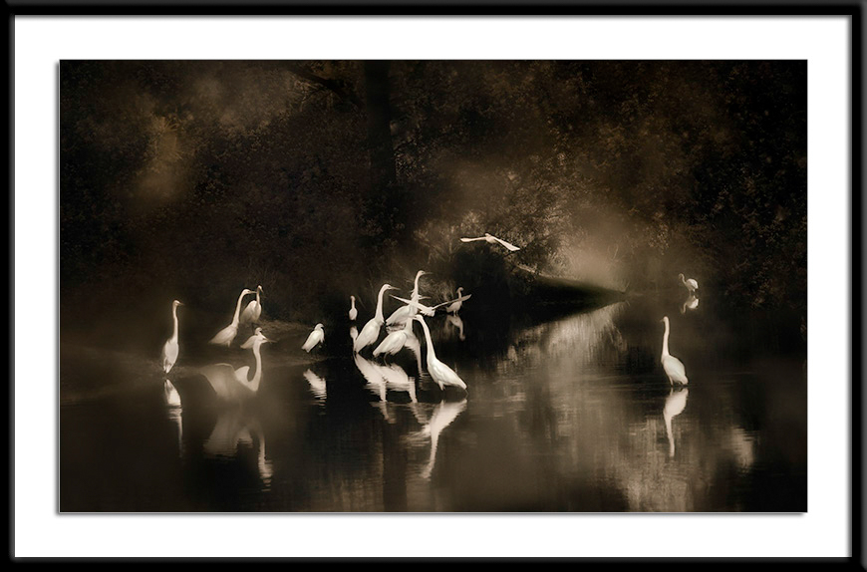
This image has won awards in some competitions and been rejected in others. Go figure!

Enter strong, visually compelling images.
Judging is frequently done as a multi-pass process. The first pass is usually just a quick run thru, but it is at this stage that important impressions are formed. By the end of the first pass the judge(s) will have a good idea which images are going to get their attention moving forward. Remember, for the better shows, the competition can be very stiff and only a certain percentage (often well less than 20%) of the entries are going to get in, so your images really have to grab the judge(s) right from the start!
You know a great photograph when you see one – and so do judges. Make them remember your images by entering original, well-crafted, high impact images.
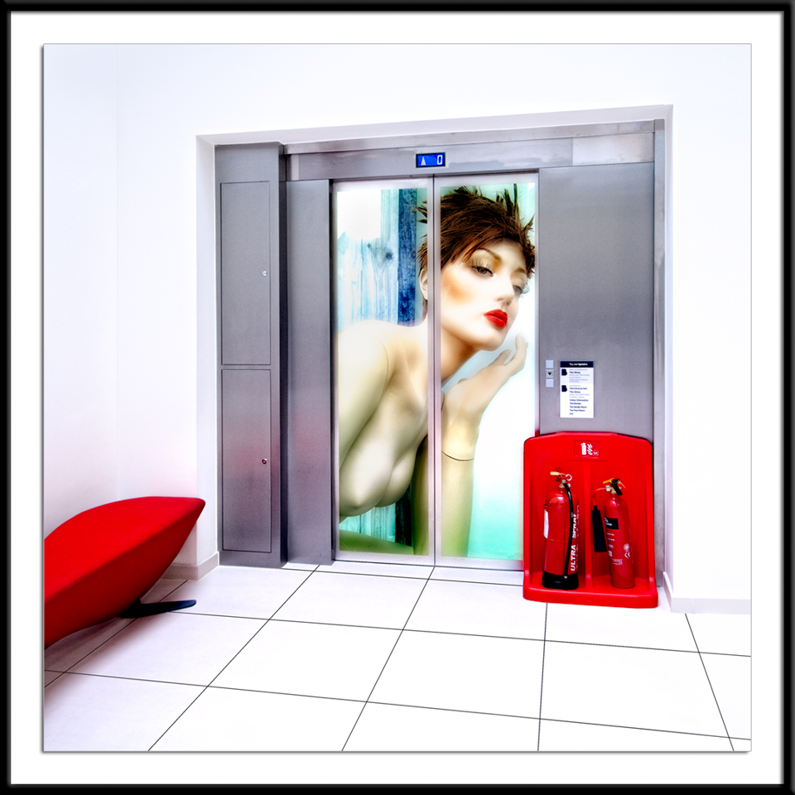
Submit images that demand that they be noticed!

Beware of iconic locations.
On the subject of stiff competition, it is important to recognize that if you enter images from iconic locations, then they really have to be great. In one of our recent shows we got over 20 entries of Times Square. Most were good, but one was spectacular and that’s the one that got in, taking an award, while knocking out the other 20+ images.
The other problem with iconic locations is that we have all seen hundreds of wonderful shots of them on Google and Flickr and those shots form our reference points when viewing / judging similar images. Portland Head Lighthouse is a great example. Unless it is covered in ice, with a shipwreck in the distance during a lightning storm, the chances are the judges have seen hundreds of similar pictures somewhere, so the image they are judging has to be really, really good to make it through.
The point here is that you are far better off submitting unique images that reflect your unique vision than a well exposed shot from tourist viewing area.

Be different!
You’d be amazed how similar many images are in a given competition and that similarity breeds boredom for the judges. You don’t want to see 27 pictures of flowers that all look basically the same and neither do the judges! Judges want to see something different, and if you provide them with what they want, your chances go up dramatically.
That doesn’t mean don’t shoot flowers, it just means don’t shoot flowers like everybody else. Look for a different angle, shoot them at f1.2, shoot them in the rain, shoot them at night, etc. Do something different that causes the judge to sit up and take notice.
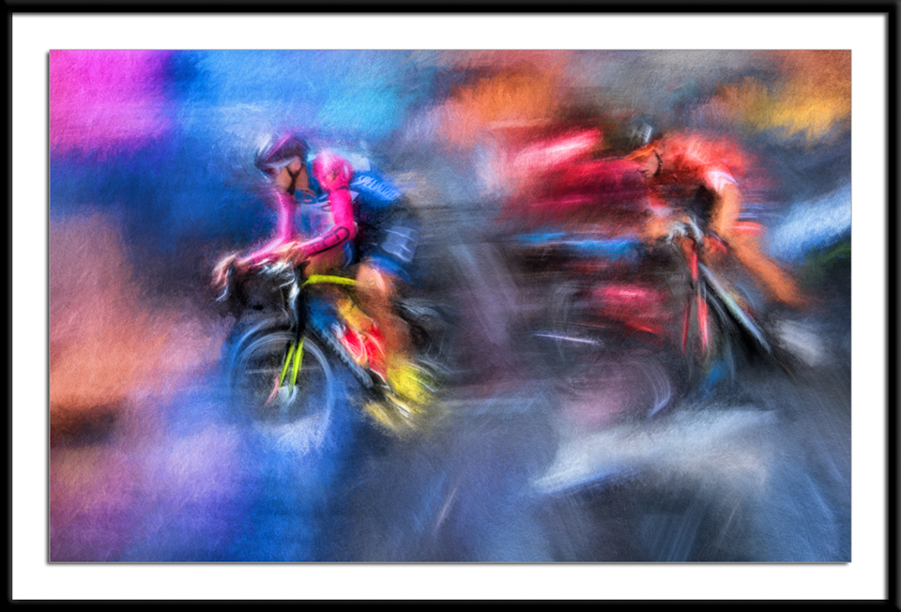
There were thousands of people at this pro bike race, most with cameras or phones clicking a way. Despite that, I’m pretty sure this image is a bit unique. 🙂

Don’t do the obvious.
Giant moons plopped behind the New York skyline in Photoshop aren’t likely to get you into many of the better shows. If you feel compelled to enter wrinkled faces make sure they have more than that going for them. Let the eyes or setting tell a story that is reinforced by wrinkles. Connect with your subject, even if it is from a distance.

Quality matters and the little things count.
Truly great images can often survive having quality issues because their content value is so striking. Henri Cartier Bresson’s images were often technically flawed, but who cares. For the rest of us, quality is important.
The number one killer of quality is blown highlights. Followed in a distant second by shadows that are too blocked up to reveal any detail. Sensor dust spots, most frequently in the sky, are another really bad black mark against an image (and the photographer). If you don’t care enough about your own image to take the time to fix the dust spots (and everyone gets them), then why should you expect a judge to care?
Horizon lines that aren’t straight are also a huge no, no! Nope, not kidding… we see this all of the time. You can get away with centering your horizon line (or subject) sometimes – OK make that very rarely. Skies should be realistically colored and very rarely are they yellow. (OK, that’s a pet peeve and maybe it doesn’t bother most people, but it does me!) Over-saturated skies are all too common and are usually a turn off to most experienced photographers / judges.
Once you have finished an image, let it set for at least a day and then go back and I’m willing to bet that you’ll find innumerable little changes that can make the photograph better. Minor changes in site-specific exposure, contrast, and tonality, fixing minor distractions, looking at better crops (never crop until you are REALLY finished with an image), etc., can all result in dramatic improvements in image quality. If you don’t think that such attention to detail is necessary, that’s fine. However, recognize that your competition to get into a show probably does know that the little things really count, and because of that, they are more likely to get in.
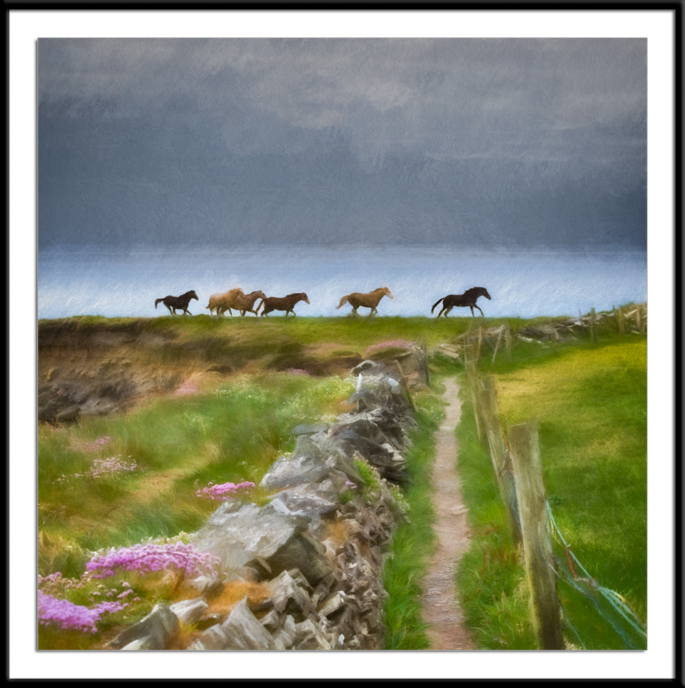
10 saved versions, 100’s of tweaks and changes and I finally got what I saw in my mind’s eye. Were the hours of work worth it? To me, absolutely. To a judge, maybe not… but that’s OK. I like it and I know all judges don’t have good taste!

Be careful with your post processing.
Nobody can accuse me of being a traditionalist when it comes to post processing. I feel totally justified in using any technique that I care to. That said, people often go too far over the top for most judges – including me. Speaking solely for myself here… if you have halos around trees or buildings you have gone way too far. Unless it is obviously intentional, if your sky is posterized you’ve gone too far. If you are going to use HDR, recognize that extending the tonality can have a discomforting effect on human skin tones that many viewers (including possibly some judges) may find unappealing. To understand why, do yourself a favor and become casually familar with the concept of the “uncanny valley”. It applies to photography as well as animation and robotics.
And now the biggie… Don’t try to save a bad image by HDRing it or throwing a paint filter or texture on it – you are not going to fool any judge I know! Those techniques are fine, but only apply them to great images to make them even better.

Composition is critical.
If I had to guess at a number, I would say that only about 30% of the images that I see when judging and doing portfolio reviews are well and thoughtfully composed. Composition to me is more than the Rule of Thirds and encompasses how each of the image elements works with the other elements to create a complete photograph. Is there a true subject? Does it relate properly to the rest of the image? Does the positioning of the elements keep the viewer engaged and visually moving through the image? The answer to all of those questions should be “yes” and the questions themselves are NOT rhetorical!

Technical perfection is not a requirement!
When the aliens land, nobody is going care if your bokeh is perfect and most judges will recognize and reward the value of the storytelling over absolute technical competence. Without a doubt, always get the shot first and then worry about the details. That said, if you have the opportunity (notice I didn’t say “time”) to work the scene and do it right, then do it. Judges (and audiences) do recognize the difference between someone who just clicks the shutter and photographers who understand their craft.

Impact vs. The Pretty Picture.
Pictures that are merely pretty are nice and have their place, but it is rare to find them on the walls of museums or serious galleries. It is also rare that they find their way into the top photo competitions or contests. That doesn’t mean that they are bad pictures, it is that the judges are expecting more. If you are going to go the pretty route, elevate your game – go for impact and make them breathtakingly beautiful. It can be the same flower, but make sure you bring your own vision and creativity to the table.
You want to have people (especially the judges) stop and really look at your picture. To do that you need to give them a compelling reason to do so. Beyond instant impact, the best images have a compelling depth to them that engages viewers and makes them really think about what they are looking at.
That doesn’t mean that your images have to be dark and distressful. It simply means that your photography should be thought provoking in some way or another if you want the judges to seriously consider it. Ask yourself, “Why did I take this picture?” If you can’t see the answer in your image, the chances are the judges won’t either.
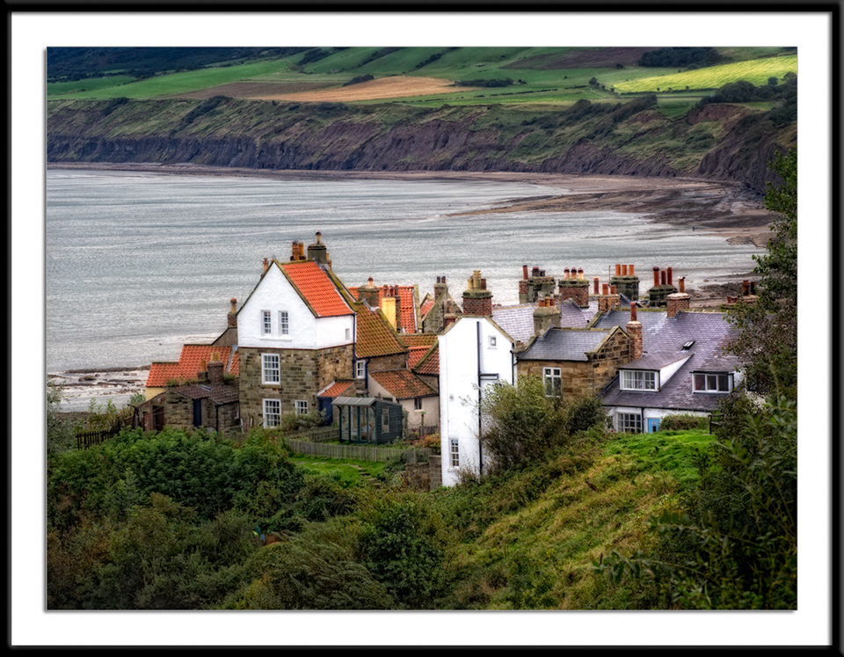
Pretty? Yes. But, if I am honest with myself, it’s just a memory shot with no real story to tell. If you “had to be there” to appreciate a shot, you should probably enter something else. That doesn’t mean don’t take pictures like this, as good memories should never be allowed to be forgotten!

Kids and Kittens.
Put up a picture of a kid or a cute animal and you’ll hear “ahhhs” from the audience. It can be a terrible photograph, but it will still draw “ahhhs”. Works every time – with audiences, but not necessarily with judges. When entering a competition, recognize that your little one (whether furred or unfurred) is the cutest thing in the world and almost everything they do is adorable – to you. However, the judge or judges aren’t privy to the same emotional connection to the subject that you have and are going to judge it based on its photographic qualities. That doesn’t mean don’t enter kid and pet pictures, it means enter really good kid and pet photographs. Think Vivian Maier rather than how cute peanut butter smeared all over the dog is.

Adhere to the theme of the show.
For example, if you are entering the PCP’s annual AMERICANA Exhibition, don’t submit photographs that were obviously and identifiably taken in Eastern Europe. If you are entering a wildlife competition, don’t submit pictures of a building. Seem obvious? Well, you’d be surprised!

Read the Prospectus!!!!
Most juried shows have a reason for doing things the way they do them. It might not be the way you would do them, but that doesn’t matter. The judges and organizers may be dealing with hundreds of people and thousands of images and need to function within an established order to maintain their sanity.
If they ask for a certain file size, send them that size. If everyone else is sending in high quality files and you send in a 67kb image, it will not show well, be judged well, or reflect on you well. Likewise, if the prospectus says not to watermark your image, don’t watermark it. If you don’t trust the competition not to steal your images, then don’t enter the competition.

Researching the Judges.
Does studying a judge’s background and own photography help in determining what types of images the judge will choose? Probably not too much unless their bio says something like “I hate HDR.”
For example, I don’t do much photojournalism and I’m not very good at it. That said, I love good photojournalism and hold it in high regard when judging. Similarly, if you look at my current work, you would have no idea that I came up as a very traditional, large format, B&W zone system based photographer. I know what a good B&W photograph should look like and don’t have much sympathy for B&W pictures that are “technically challenged.”
When all is said and done, it is probably a better use of your time to refine your images to their highest levels than it is to try to guess what judges will like on a particular day.

